Given a 2D Array, :
1 1 1 0 0 0
0 1 0 0 0 0
1 1 1 0 0 0
0 0 0 0 0 0
0 0 0 0 0 0
0 0 0 0 0 0
We define an hourglass in to be a subset of values with indices falling in this pattern in 's graphical representation:
a b c
d
e f g
There are hourglasses in , and an hourglass sum is the sum of an hourglass' values. Calculate the hourglass sum for every hourglass in , then print the maximum hourglass sum.
For example, given the 2D array:
-9 -9 -9 1 1 1
0 -9 0 4 3 2
-9 -9 -9 1 2 3
0 0 8 6 6 0
0 0 0 -2 0 0
0 0 1 2 4 0
We calculate the following hourglass values:
-63, -34, -9, 12,
-10, 0, 28, 23,
-27, -11, -2, 10,
9, 17, 25, 18
Our highest hourglass value is from the hourglass:
0 4 3
1
8 6 6
Note: If you have already solved the Java domain's Java 2D Array challenge, you may wish to skip this challenge.
Function Description
Complete the function hourglassSum in the editor below. It should return an integer, the maximum hourglass sum in the array.
hourglassSum has the following parameter(s):
- arr: an array of integers
Input Format
Each of the lines of inputs contains space-separated integers .
Constraints

Output Format
Print the largest (maximum) hourglass sum found in .
Sample Input
1 1 1 0 0 0
0 1 0 0 0 0
1 1 1 0 0 0
0 0 2 4 4 0
0 0 0 2 0 0
0 0 1 2 4 0
Sample Output
19
Explanation
contains the following hourglasses:
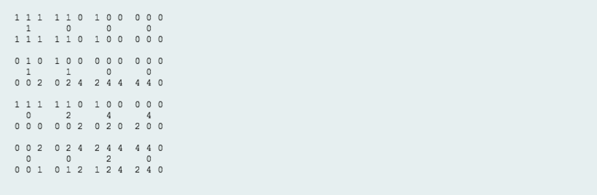
The hourglass with the maximum sum () is:
2 4 4
2
1 2 4

Solution:

import java.io.*;
import java.math.*;
import java.security.*;
import java.text.*;
import java.util.*;
import java.util.concurrent.*;
import java.util.regex.*;

public class Solution {

// Complete the hourglassSum function below.
static int hourglassSum(int[][] arr) {
int[][] arrResult = new int[4][4];
int[][] subArray = new int[3][3];
int tempSum;
int resultColCounter = 0;
int maxSum;

for(int i=0; i<4; i++) {
for(int nextSet = 0; nextSet < 4; nextSet++) {

int counter = 0;
for(int j=i; j< i+3; j++) {
subArray[counter] = Arrays.copyOfRange(arr[j], nextSet, (nextSet+3));
counter++;
}

// Initializing temporary sum to '0'
tempSum = 0;

// Now calculate the sum all numbers in "subArray"
for(int row=0; row < subArray.length; row++) {
for(int col=0; col < subArray[0].length; col++) {
tempSum += subArray[row][col];
}
}

// Remove [1][0]th and [1][2]th element value from "tempSum"
tempSum -= subArray[1][0];
tempSum -= subArray[1][2];

//System.out.println("Final sum is: " +tempSum);

// Push the element into "arrResult"
arrResult[i][resultColCounter] = tempSum;

// Increment the "resultColCounter" value
resultColCounter++;
if(resultColCounter == 4)
resultColCounter = 0;

}
}

// Find maximum sum from all sums of hourglasses
for(int row=0; row<arrResult.length; row++) {
for(int col=0; col<arrResult[0].length; col++) {
if(arrResult[row][col] > maxSum)
maxSum = arrResult[row][col];
}
}

// Initialize first element from 2D array as max value
maxSum = arrResult[0][0];

for(int row=0; row<arrResult.length; row++) {
for(int col=0; col<arrResult[0].length; col++) {
System.out.print(arrResult[row][col]+ " ");
}
System.out.println();
}

return maxSum;
}

private static final Scanner scanner = new Scanner(System.in);

public static void main(String[] args) throws IOException {
BufferedWriter bufferedWriter = new BufferedWriter(new FileWriter(System.getenv("OUTPUT_PATH")));

int[][] arr = new int[6][6];

for (int i = 0; i < 6; i++) {
String[] arrRowItems = scanner.nextLine().split(" ");
scanner.skip("(\r\n|[\n\r\u2028\u2029\u0085])?");

for (int j = 0; j < 6; j++) {
int arrItem = Integer.parseInt(arrRowItems[j]);
arr[i][j] = arrItem;
}
}

int result = hourglassSum(arr);

bufferedWriter.write(String.valueOf(result));
bufferedWriter.newLine();

bufferedWriter.close();

scanner.close();
}
}

